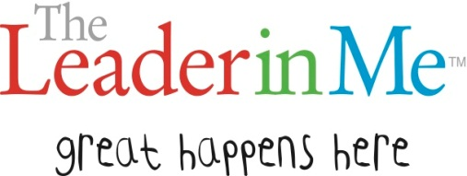
A leader looks like…

“If we keep doing what we’re doing, we’re going to keep getting what we’re getting.” -- Stephan Covey
I lead by _______________________ ________________________________________________________________________________________________________________________

The habit that has impacted me the most is____________________________ because_________________________________________________________________________________________________________________________________________________

